**COAL LAB**

**LAB 11**

**Name: Muhammad Sultan Student ID: 11018**

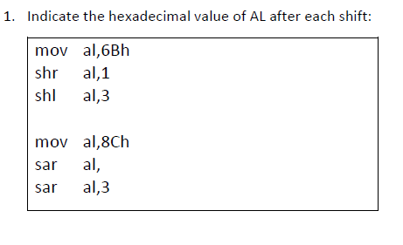

**Answer to Question:**

